**Ideation Phase**

**Define the Problem Statements**

| Date | 26-06-2025 |
| --- | --- |
| Team ID | LTVIP2025TMID59448 |
| Project Name | ShopSmart |
| Maximum Marks | 2 Marks |

**Customer Problem Statement Template:**

To define the core problems customers and small vendors face in the traditional grocery shopping experience, and use those insights to guide the development of ShopSmart, a digital grocery store platform.

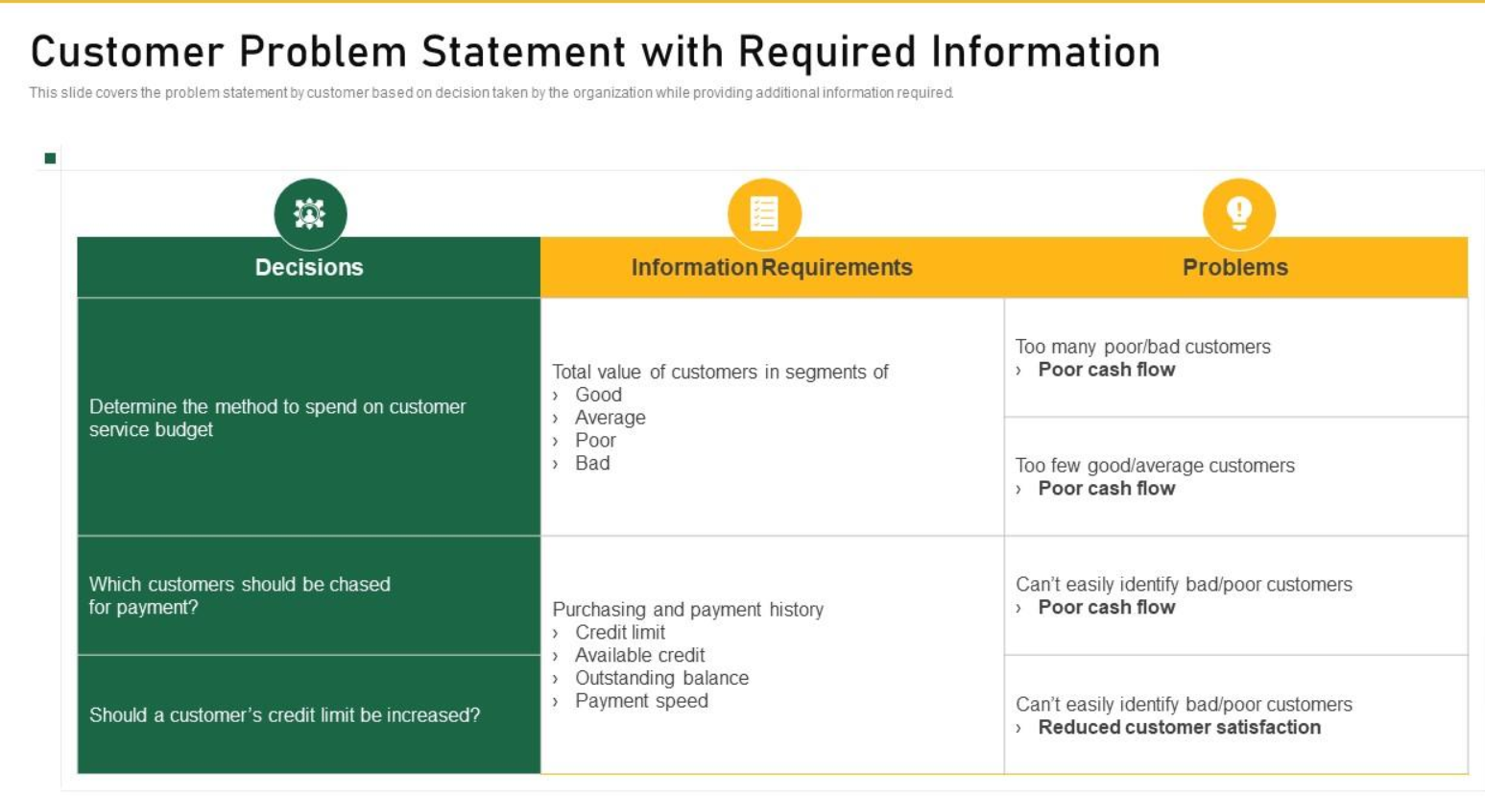

### **PS-1: Customer (Busy Shopper)**

**I am** a working parent with limited free time.  
 **I’m trying to** buy groceries efficiently without going to crowded stores.  
 **But** local grocery shops don’t offer easy online ordering or real-time product availability.  
 **Because** they rely on manual systems and lack digital tools.  
 **Which makes me feel** stressed and frustrated as I struggle to manage time between work and home.

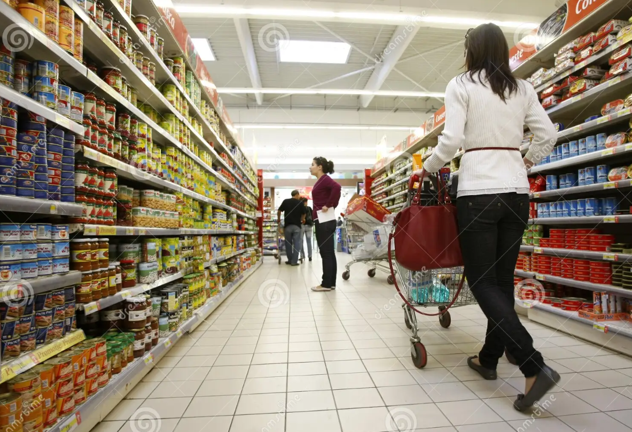

### **PS-2: Vendor (Small Grocery Store Owner)**

**I am** a small grocery store owner in a semi-urban area.  
 **I’m trying to** increase sales and manage inventory more effectively.  
 **But** I don’t have access to simple, affordable digital platforms to reach online customers.  
 **Because** most e-commerce solutions are too complex or expensive for small businesses.  
 **Which makes me feel** anxious and disadvantaged in the growing digital marketplace.

